**Bahria University,**

Karachi Campus



## LAB EXPERIMENT NO.

## 5

## LIST OF TASKS

|  |  |
| --- | --- |
| **TASK NO** | **OBJECTIVE** |
| **1** | Using python implement Naïve Bayes with two different splitting ratios on Heart Attack Analysis & prediction dataset to predict the chances of heart failure in a person and performed the following steps: ▪ Data Pre-processing step ▪ Fitting Naive Bayes to the Training set ▪ Predicting the test result ▪ Test accuracy of the result(Creation of Confusion matrix) ▪ Visualizing the test set result. ▪ Compare the accuracies |
| **2** | Design a workflow with the help of Knime to predict whether a user buys a product by clicking the ad on the site based on their salary, age, and gender dataset provided in the lab (i.e. Social network ad dataset). |

**Submitted On:**

18 feb 2024

(Date: DD/MM/YY)

**TASK 1:** Using python implement Naïve Bayes with two different splitting ratios on Heart Attack Analysis & prediction dataset to predict the chances of heart failure in a person and performed the following steps: ▪ Data Pre-processing step ▪ Fitting Naive Bayes to the Training set ▪ Predicting the test result ▪ Test accuracy of the result(Creation of Confusion matrix) ▪ Visualizing the test set result. ▪ Compare the accuracies

import pandas as pd

from sklearn.model_selection import train_test_split

from sklearn.preprocessing import StandardScaler

from sklearn.naive_bayes import GaussianNB

from sklearn.metrics import confusion_matrix, accuracy_score

import matplotlib.pyplot as plt

import numpy as np

file_path = 'heart_failure_clinical_records_dataset.csv'

data = pd.read_csv(file_path)

data.head(), data.info(), data.describe()

X = data.drop("DEATH_EVENT", axis=1)

y = data["DEATH_EVENT"]

scaler = StandardScaler()

X_scaled = scaler.fit_transform(X)

X_train_70, X_test_70, y_train_70, y_test_70 = train_test_split(X_scaled, y, test_size=0.3, random_state=42)

X_train_80, X_test_80, y_train_80, y_test_80 = train_test_split(X_scaled, y, test_size=0.2, random_state=42)

def train_evaluate_nb(X_train, X_test, y_train, y_test):

    classifier = GaussianNB()

    classifier.fit(X_train, y_train)

    y_pred = classifier.predict(X_test)

    cm = confusion_matrix(y_test, y_pred)

    accuracy = accuracy_score(y_test, y_pred)

    return cm, accuracy, y_pred

cm_70, accuracy_70, _ = train_evaluate_nb(X_train_70, X_test_70, y_train_70, y_test_70)

cm_80, accuracy_80, _ = train_evaluate_nb(X_train_80, X_test_80, y_train_80, y_test_80)

cm_70, accuracy_70, cm_80, accuracy_80

def plot_confusion_matrix(cm, title='Confusion Matrix'):

    plt.figure(figsize=(5,4))

    plt.imshow(cm, interpolation='nearest', cmap=plt.cm.Blues)

    plt.title(title)

    plt.colorbar()

    tick_marks = np.arange(2)

    plt.xticks(tick_marks, ['No Heart Failure', 'Heart Failure'], rotation=45)

    plt.yticks(tick_marks, ['No Heart Failure', 'Heart Failure'])

    plt.tight_layout()

    plt.ylabel('True label')

    plt.xlabel('Predicted label')

    for i in range(cm.shape[0]):

        for j in range(cm.shape[1]):

            plt.text(j, i, cm[i, j], horizontalalignment="center", color="white" if cm[i, j] > cm.max() / 2. else "black")

    plt.show()

plot_confusion_matrix(cm_70, title='Confusion Matrix (70:30 Split)')

plot_confusion_matrix(cm_80, title='Confusion Matrix (80:20 Split)')

plot_confusion_matrix(cm_70, title='Confusion Matrix (70:30 Split)')

plot_confusion_matrix(cm_80, title='Confusion Matrix (80:20 Split)')

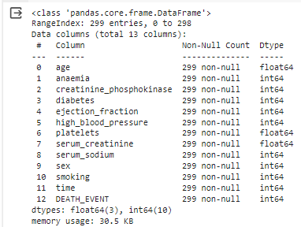

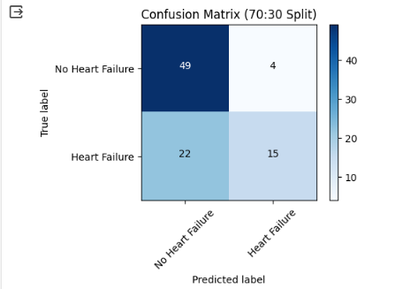

**TASK # 2**: Design a workflow with the help of Knime to predict whether a user buys a product by clicking the ad on the site based on their salary, age, and gender dataset provided in the lab (i.e. Social network ad dataset).

